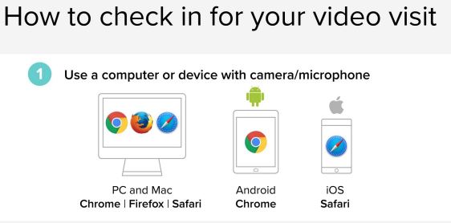
CLICK ON THE LINK- sent to your email address OR in your text message
You will see the box below: Enter your First and Last name, then click Check In!

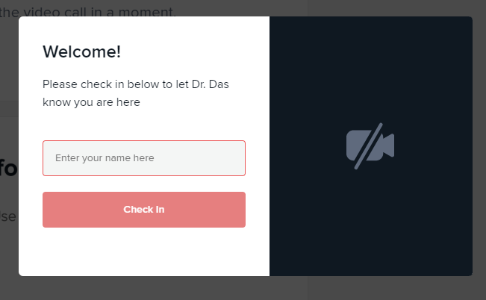

If requested: Enable your Camera/Sound and Hit Allow
Your Care Provider will start your visit!
